CTS WEEK – 2
Exercise 1: Configuring a Basic Spring Application
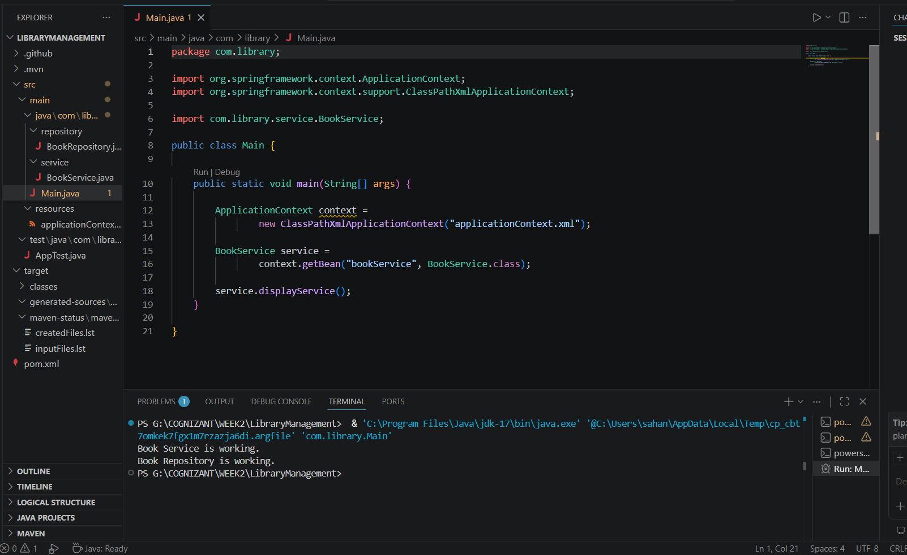

Exercise 2: Implementing Dependency Injection
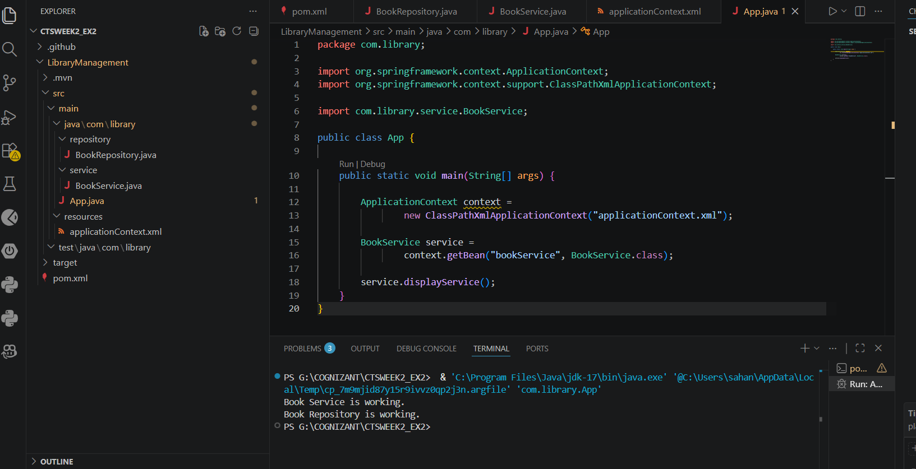

Exercise 4: Creating and Configuring a Maven Project
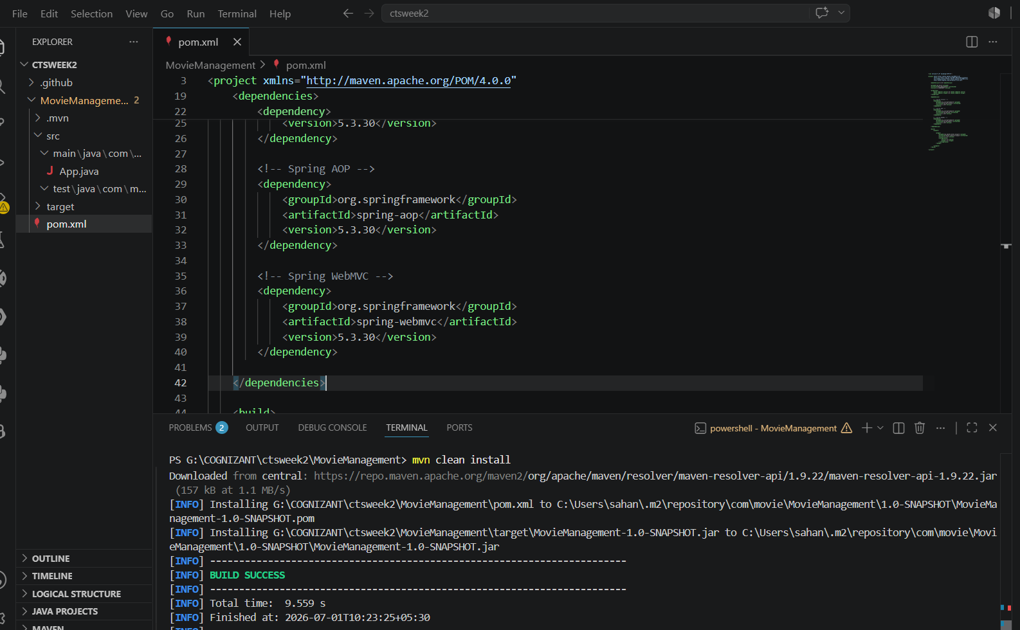

Hands on 1
Spring Data JPA - Quick Example
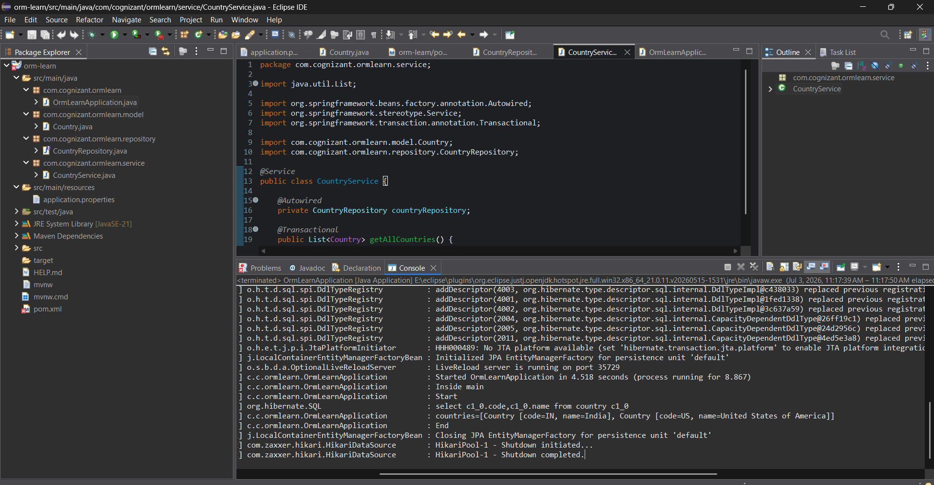

Hands on 4
Difference between JPA, Hibernate and Spring Data JPA
